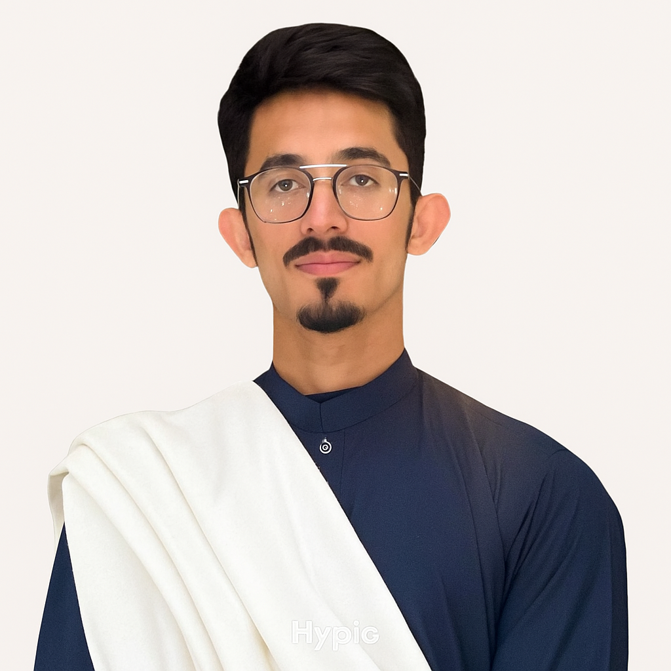

Skills
- Technical skills: DNA Extraction . PCR . Programming · Scientific Paper Research · Bioinformatics Tools · Laboratory Techniques · Data Handling and Analysis

- Soft Skills : Teamwork · Quick Learner · Detail-Oriented · Critical Thinking · Time Management · Problem Solving

Education
Bachelor of Science (BS) in Biosciences
COMSATS University Islamabad
Expected Graduation: 2025
- Final Year Project: Genetic Analysis of Gallbladder Stone-Associated Genes

FSc (Pre-Medical)
JS Public School and College, Rawalpindi
Passed: 2021

Hobbies
- Football and ice skating
- Strategy-based card and board games
- Deep interest in Poetry & philosophy
Brief Profile:
Final-year Biosciences undergraduate at COMSATS University Islamabad with a strong foundation in laboratory techniques and Research. Currently working on a final year project focused on the genetic basis of gallbladder stones, with a keen interest in molecular biology and disease-related genomics. Skilled in computer-based analysis, paper research, and coding in Python, with a growing interest in applying modern tools and techniques in medical research. Experienced in group assignments, scientific presentations, and hands-on lab work throughout the degree. Highly motivated to pursue a Master’s in the field of research, with strengths in teamwork, digital proficiency, and deep analytical thinking.

Experience
Event Volunteer – WWF Seminar
COMSATS University Islamabad · 2025
- Assisted in organizing and managing a university seminar conducted in collaboration with WWF.
- Supported event logistics, coordinated with attendees and speakers, and ensured smooth flow of activities.

Member & Event Coordinator – C3 Society
COMSATS University Islamabad · 2023–2024
- Actively contributed to planning and organizing university-level events, workshops, and student engagement activities.
- Managed event setups, helped coordinate with teams, and facilitated smooth execution of multiple society functions.

Degree/Class Projects (If any)

Cell No. : 03335931889 Email: shirazi6503@gmail.com Linkdin: www.linkedin.com/in/syedmuhamadalishirazi

Syed Muhammad Ali Shirazi

